

Content
- Chapter 1: The Innovation
  - Product Name and Purpose
  - Watch Components and System Integration
  - Main Product Features and How It Works
1.4 Stage of Development
- Chapter 2: Target Market, Market Validation, Opportunity Analysis, and Demand creation
  - Market Opportunity and competitive position
  - Customer Segmentation
  - Marketing validation
  - Geographic market segmentation
2.4.1 Canada
2.4.2 Chile
  - Market consideration
- Chapter 3: Ventures Vision and Business Model
3.0 The Ventures Vision and Business Model
3.1 Ventures Vision
3.2 Business model
3.3 Value Proposition
- Chapter 4: Intellectual Property
4.1 IP strategy
4.2 IP assets and why each matter
4.3 Countries and Timeline
4.4 Estimated Costs
4.5 Existing IP and Overseas Protection
- Chapter 5: Talent and Team Capabilities and Scaling Up Excellence
5.1 Company Overview
5.2 Human Resources
5.3 Financial Resources
5.4 Operational Resources
5.5 Scaling Strategy
- Chapter 6: Resourcing and Operational Plan
6.1 Preparation
6.2 Balance Sheet
6.3 Income Statement
6.4 Revenue and cost drivers
6.5 Limitations
- Appendices
- References

Chapter 1: The Innovation

1.1 Product Name and Purpose
The innovation is an MRMON watch that acts as an underground worker safety wearable device. This device serves as a safety layer that links early signs from a worker’s body and hand-raised distress calls with exact location information. It helps emergency services respond quickly. In underground mines and rail construction sites, GPS and Wi-Fi signals do not get through. This makes workers more exposed to health or environmental dangers that go unnoticed. Also, current tracking systems tend to slow down help by sending alerts only to control rooms instead of telling nearby people who can act right away.
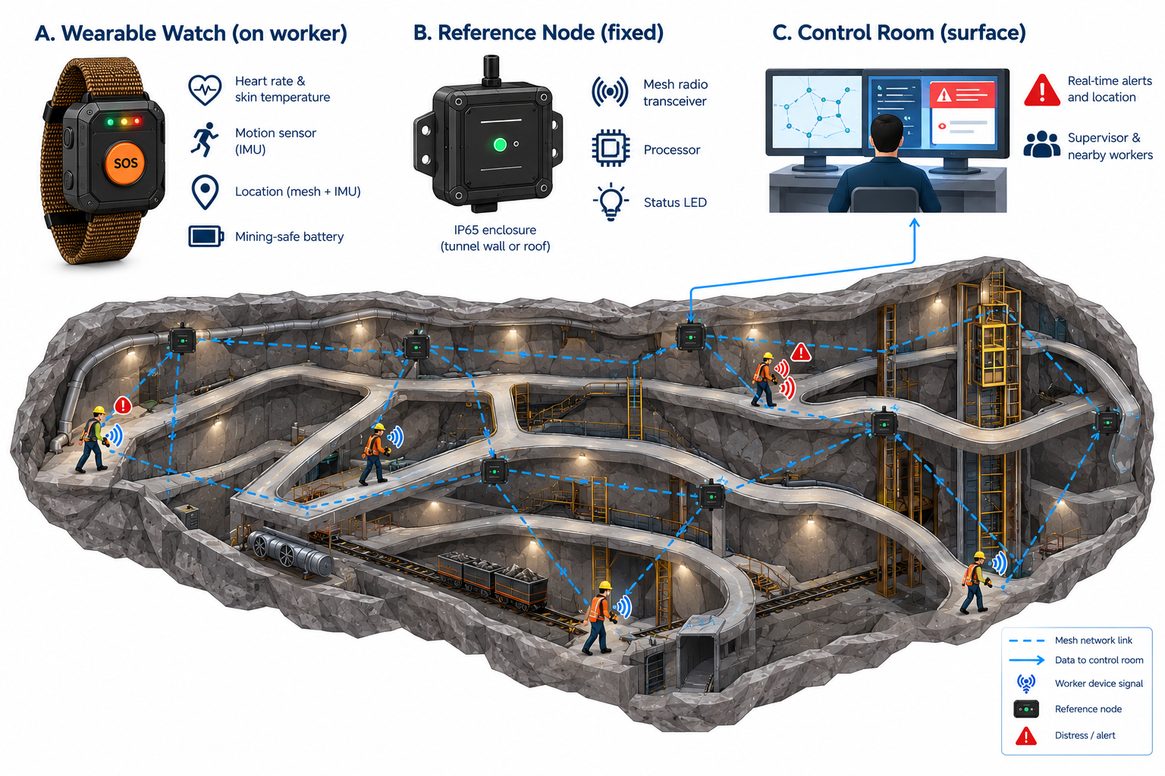
Figure 1 Interaction between Nodes and Watch

1.2 Watch Components and System Integration
Two important hardware parts run the system. They were made on purpose to survive industrial places and work with the old setup at a site:
- The Wearable Watch (Appendix 1): It is covered in an IP67-rated shell. This shell is anti-static. Won't catch fire. The watch has a band made from woven material that's strong against heat and rough surfaces. This band helps spread the weight, so it feels comfortable on the wrist. Inside, a small, printed circuit board has a mesh radio chip, a motion sensor (IMU), and sensors that check heart rate and skin temperature. It uses a battery that is safe for mining areas.
- Reference Nodes (Appendix 2): These are fixed parts of the setup. They have an enclosure that is rated IP65. This enclosure is strong. Has a mesh radio transceiver, a processor inside, and a LED that shows the status. These nodes can be attached to tunnel walls or roof supports every 50 to 150 meters. They can use electricity or a strong internal battery.
The two parts communicate with each other through a network that fixes itself if something goes wrong. This network works without GPS or Wi-Fi. As workers walk through the tunnels, their watches send real-time information about their bodies and where they are to the fixed node. These nodes pass the information up to the control room on the surface. They also let the devices talk directly to each other to warn workers if there is a problem (Figure 1).

1.3 Main Product Features and How It Works
The device is designed for harsh underground environments and includes specialized features such as:
- Kalman-Filtered Location Tracking: This watch uses a peer-to-peer mesh network that connects devices and reference nodes. This makes it possible to track workers in real time, even when GPS does not work. The software uses a Kalman filter to improve the location data by combining it with readings from sensors (IMU). This removes any impossible position changes.
- Biometric Man-Down Triage: The wearable device constantly checks for vital signs and movement. It compares the data with safety limits that were set beforehand, so that when a big change appears, the device sends a distress signal. This reduces the number of alarms.
- Dual Notification System (Decentralized Response): When a worker crosses a danger limit or presses the SOS button, the system automatically sends alerts at that time to the control room supervisor, as well as nearby colleagues. That way, help can be sent as soon as possible.
- Glove-Friendly, Screenless Interface: The watch relies on a tri-color status LED (green, yellow, flashing red) and a haptic vibration motor, allowing workers to "feel" their safety status even in low light or heavy dust. A single, mechanical button is used for communication, with only one press triggering a manual distress signal, two presses issuing an all-clear, and three presses initiating a site-wide alert.
- Zero-Configuration Deployment: The network nodes use a self-healing mesh protocol. When a new node is installed in the tunnel to extend operational range, it will automatically join the existing network. This ensures easier scalability for the safety monitoring coverage area.

1.4 Stage of Development
MRMON has built a working prototype and a minimum viable product (MVP) and has tested it in a simulated, enclosed tunnel environment. The product is not yet certified, has not yet been trialed at a live mine site, and is not yet ready for commercial sale. This section sets out what is complete and what remains. The same milestones are used in Chapter 5.5, and the cost of the remaining work is set out in Chapter 5.3.
Completed: the prototype and MVP; bench and simulated-tunnel testing; and an industrial design with a multi-sensor integrated PCB, haptic feedback and a mining-grade battery in an IP67-rated casing, which is finalized for a pilot-batch build subject to the refinement and design review described below. Core intellectual property, including the algorithms that classify worker status from biometric data and the zero-configuration, self-healing mesh network protocol, is protected by an Australian standard patent granted in September 2026 (Chapter 4). A granted patent protects the invention; it does not mean that the product has been certified or approved for use underground.
Remaining (Months 0–18 from seed close): further refinement of the MVP with PCB changes (and possible design changes); compliance work (ingress, EMC/radio and applicable requirements); production preparation for pilot batches; and field validation with a paid pilot on an appropriate site assessed as suitable. This work is included in the budget (Chapter 5.3) under items of MVP refinement, validation and production preparation (AUD $110,000), certification and compliance (AUD $135,000) and field trials (AUD $40,000) but not as new product development.

Chapter 2: Target Market, Market Validation, Opportunity Analysis, and Demand Creation

2.1 Market Opportunity and competitive position
Australia has a well-established mining industry and holds the world’s largest demonstrated economic resources of nine mineral commodities in 2024. Mineral resource exports totaled approximately AUD 308 billion, equivalent in value to 11% of GDP. Iron ore accounted for 41% of mineral export income, coal 28%, and gold 12% (Hughes et al., 2026). Mining employed approximately 314,500 people in February 2026, representing 2.1% of national employment (Jobs and Skills Australia, 2026). These totals cover the broader industry, not eligible for MRMON users, and provide context rather than proof of product demand.
The industry recorded 10 work-related traumatic injury fatalities in 2024, equivalent to 3.4 per 100,000 mining workers (Safe Work Australia, 2025). These figures concern traumatic injuries rather than all occupational deaths or illnesses. They highlight safety risks but do not establish that MRMON would have prevented these fatalities. MRMON will initially target underground metalliferous mining operators in New South Wales (NSW), restricting deployment to sites suitable for its initial non-gassy application and applicable approvals. Aurelia Metals’ Peak operation and Evolution Mining’s North Parkes operation are the first two researched prospects because both include underground mining activities (Aurelia Metals, n.d.; Evolution Mining, n.d.). Site suitability, compatibility, and commercial interest require direct engagement.
NSW’s 2025 coal-industry figures identified 16 underground mines and one mixed underground/open-cut operation among 36 producing coal mines. These provide regional context, not a count of eligible customers for MRMON’s initial segment (NSW Productivity and Equality Commission, 2025). MRMON combines worker-location information, worker status, and emergency alerts in a screenless wrist device with a physical button designed for use with gloves. Its workflow provides location-linked notifications to supervisors and designated nearby co-workers.
Relevant competitors include SlateSafety BAND V2, which offers physiological monitoring, indoor location tracking, SOS alerts, and no-movement detection, and Strata CommTrac, which provides underground tracking and communications. MRMON’s positioning emphasizes its wrist interface and coordinates alert workflows without claiming exclusive functionality or faster responses. Appendix B provides a comparison. The initial sales target is one paid pilot at AUD 60,000. Securing one at each shortlisted operation would generate AUD 120,000. Each package includes 60 wearables and 30 reference nodes. These are planning scenarios, not confirmed sales or the total Australian market. Appendix C details the assumptions.

2.2 Customer Segmentation
The initial primary purchasing customers are underground metalliferous mining operators in New South Wales (NSW), while underground workers are the principal end users of the proposed wearable. The purchasing decision involves several stakeholder groups with different responsibilities and priorities. Safety managers assess whether the product supports workplace safety procedures; operational supervisors evaluate its suitability for underground conditions, and procurement managers review system compatibility, deployment requirements, and overall cost.
The principal customer stakeholders can therefore be divided into three groups:
- Underground workers: the principal end users who require a simple, durable, and accessible device that can be operated while wearing protective equipment.
- Supervisors and safety personnel: the operational decision makers who require clear worker location information, emergency alerts, and actionable information during an incident.
- Operations and procurement managers: the organizational purchasing group responsible for evaluating installation requirements, system compatibility, supplier reliability, ongoing support, and total deployment cost.

2.3 Market Validation
Between 1 and 28 September 2026, the project team conducted face-to-face and telephone interviews with 100 participants recruited through LinkedIn and contacts with Australian engineers. The sample comprised 60 underground workers, 25 supervisors and safety personnel, and 15 operations and procurement managers. Open-ended interviews explored underground work challenges, unmet needs, and management concerns. Responses were grouped into recurring themes, counting each respondent once per relevant theme.

Participant group | Sample composition | Priority identified | Product implication
Underground workers | 60 participants (60%) | 48 of 60 participants (80%) prioritize the ability to operate the device while wearing gloves. | Accessible physical controls suitable for use with protective equipment.
Supervisors and safety personnel | 25 participants (25%) | 21 of 25 participants (84%) prioritize receiving worker-location information alongside emergency alerts | Combined worker location and emergency alert notifications
Operations and procurement managers | 15 participants (15%) | 12 of 15 participants (80%) prioritize compatibility with existing systems | Integration with site infrastructure and communication systems
Table 2 Customer segment validation results

The findings support accessible controls, location-linked alerts, and system integration as design and marketing priorities. However, recruitment was not random, and interpreting open-ended responses involves judgement. The results reflect the interviewed sample and do not independently establish willingness to pay, purchasing commitments, or expected sales. Appendix A provides the methodology, interview questions, and anonymized results.

2.4 Geographic Market Segmentation
The company’s geographic market strategy is to launch in Australia, followed by Canada and Chile as future expansion markets.

2.4.1 Australia
Australia is the initial market, beginning with qualified underground metalliferous operations in NSW. Engagement with Peak and North Parkes will establish site requirements and potential pilot opportunities before broader Australian outreach.

2.4.2 Canada
Canada is planned as the first international market in Year 3. In 2024, its minerals and metals sector directly employed approximately 438,000 people, including around 124,000 in mining and related support activities. Canada produced 60 minerals and metals at almost 200 mines, with production valued at CAD 64.3 billion (Natural Resources Canada, n.d.). These broad totals do not represent eligible MRMON customers. Entry preparation will assess underground prospects, regulations, infrastructure, and local partners.

2.4.3 Chile
Chile is planned as the second international market in Year 4. Underground operations such as Codelco’s El Teniente support further investigation of worker-location and emergency-communication needs (Codelco, n.d.). This does not imply customer interest. Entry will depend on local validation, regulatory requirements, technical compatibility, Spanish-language support, and suitable partners.

2.5 Marketing Considerations
MRMON’s business-to-business marketing will emphasize accessible operation, actionable alerts, compatibility, and total cost. Channels will include direct outreach to Peak and North Parkes, on-site demonstrations, industry exhibitions, the company's website, and equipment supplier partnerships.

2.5.1 Demand Creation
The commercial lead will engage with safety, operations, and procurement representatives. The technical lead will assess site suitability, approvals, and integration. Qualified prospects will receive demonstrations and paid pilot proposals covering scope, responsibilities, costs, and acceptance criteria.
Pilots will showcase glove-friendly operation, location accuracy, communication reliability, and emergency alerts under site conditions. Customer reviews against agreed performance, compatibility, support, and cost criteria will inform purchasing approval and phased rollout. Establishing a reference customer is a planned outcome. Planning assumptions allow three to six months for engagement and qualification, followed by an eight- to twelve-week operational pilot, subject to approvals and site arrangements. Wearables are priced at AUD 999 each, reference nodes at AUD 1,499 each, and annual software and support at AUD 300 per wearable. The AUD 60,000 pilot package includes 60 wearables, 30 nodes, installation, training, and 12 months of software and support. Financial projections appear in Chapter 6; pilot revenue scenarios appear in Appendix C.

Chapter 3: Ventures Vision and Business Model

3.1 Ventures Vision
Our vision is to better the lives of all underground workers, a goal our product works towards by improving their safety systems.
MRMON’s long-term goal is to establish itself as a trusted provider of underground worker safety technology, serving Australia’s mining industry initially, then expanding out into international mining and underground construction markets.

3.2 Business Model
MRMON will operate through a Business-to-Business (B2B) model, selling its products directly to underground mining operators instead of individual workers. Our customers will primarily consist of mining companies, with safety managers, operations supervisors and procurement teams involved in purchasing decisions.
Initially, the business will earn revenue through paid site pilots, where mining operators will be able to evaluate the system before committing to a larger purchase. The cost of each pilot will be A$60,000 and provide 60 wearable devices, 30 reference nodes, installation, training, and 12 months of software and technical support. During the pilot period, MRMON will retain ownership of the equipment, which will reduce the initial commitment of the customer whilst allowing the company to demonstrate the system’s performance under actual operating conditions.
Following successful pilot evaluation, the company will transition customers towards direct hardware purchases combined with annual software and support subscriptions. By taking this approach, revenue will be created from initial equipment sales while establishing recurring income through ongoing customer relationships.
This model will be supported through direct engagement with mining operators, equipment supplier partnerships, and demonstrations at suitable underground facilities. The Business Model Canvas and Value Proposition Canvas in Appendix D (figures D1 and D2, respectively) illustrate how the company will create, deliver, and capture value.

3.3 Value Proposition
MRMON creates value by addressing three major challenges faced by underground mining operations: monitoring worker safety, locating workers when GPS is unavailable, and coordinating emergency responses.
- For underground workers, the wearable provides a durable, screenless interface with physical controls suitable for operation while wearing gloves. Its movement and biometric sensors support the identification of potentially dangerous conditions, while the SOS function allows workers to request assistance directly.
- For supervisors and safety personnel, the system combines worker-location information with emergency notifications, providing more actionable information when responding to incidents. Alerts can also reach designated nearby colleagues rather than relying exclusively on communication through the surface control room.
- For mining operators, the reference nodes and self-healing mesh communication network are designed to extend monitoring coverage throughout underground environments without depending on conventional GPS or Wi-Fi connectivity. The system is intended to complement existing safety procedures and infrastructure, with site compatibility established during deployment assessment.
These features respond directly to the customer priorities identified in Chapter 2, where workers emphasised glove-friendly operation, supervisors prioritised location-linked emergency notifications and procurement representatives highlighted system compatibility.
Revenue will be generated through 3 main streams:
- Paid pilot deployments, as explained above in 3.2
- Hardware sales: following successful evaluations, mining operators will be able to purchase MRMON wearable devices for A$999 each and reference nodes for A$1,499 each, with hardware quantities depending on workforce size, underground infrastructure, and required monitoring coverage.
- Annual software and support subscriptions: customers will pay A$300 annually per wearable for continued access to the monitoring platform and agreed technical support. This means that, as an example, a mine operating 60 wearables would generate A$18,000 in annual subscription revenue.
At these standard listed prices, a deployment consisting of 60 wearables and 30 reference nodes would generate A$104,910 in hardware revenue, alongside A$18,000 in annual software and support revenue. This represents A$122,910 in combined first-year revenue, excluding any additional site-specific costs not covered by the standard package.
By combining hardware sales with recurring subscriptions, MRMON aims to establish a more sustainable revenue model than relying solely on one-time device purchases. As the number of customer sites and deployed wearables increases, recurring software and support revenue will become increasingly important to the business.

Chapter 4: Intellectual Property

4.1 IP strategy
Our IP strategy covers two asset groups: the integrated underground mining safety watch-and-response system and the MRMON brand. The company holds an Australian standard patent for the technical system and separate Australian trademark registrations for the name and logo. Related overseas patent applications will form part of the same patent family
Initial Australian applications were filed in December 2025, followed by a PCT application in January 2026. An early Australian national-phase entry and expedited examination supported the Australian patent grant in September 2026. Both Australian trademarks were registered in August 2026. International trademark applications will follow in October-December 2026.
Our protection plan supports Australian operations in Years 1-2, followed by expansion into Canada in Year 3 and Chile in Year 4. We have allocated AUD $75,000 for the initial IP plan. Estimated costs total AUD $67,185, including a 15% contingency.
4.2 IP assets and why each matter
- Watch and integrated safety system: One patent family covers the technical interaction between movement and impact sensing, biometric assessment, three-tier distress controls, LED and haptic feedback, underground communication and emergency alerts. Established positioning and Kalman filtering methods themselves are not claimed as our invention. The Australian patent protects the claimed mechanism against copying, supports licensing opportunities and strengthens investor confidence. Overseas protection depends on the claims granted in each country.
- MRMON name and logo: The company holds separate Australian trademark registrations for the name and logo. Each covers Class 9 for the safety device, reference nodes and embedded firmware, and Class 42 for the hosted monitoring and alert-escalation service. Overseas applications will cover the same branding. Separate registrations will protect the name independently of the logo and support customer recognition. The name registration can remain if the logo changes, although a redesigned logo may require a new application.

4.3 Countries and timeline
Australia is the initial market, followed by Canada in commercial Year 3 and Chile in commercial Year 4, consistent with Chapter 2. Entry depends on customer validation, local partnerships, technical compatibility and deployment requirements.
Month 0 refers to the Australian provisional patent filing in December 2025. The PCT application followed in Month 1. Early Australian national-phase entry and expedited examination supported the standard patent grant in Month 9, following trademark registrations in Month 8.
Separate Madrid applications for the name and logo are planned for Months 10–12, following clearance searches. A commercial review in Month 24 will confirm the countries selected for patent national-phase entry, due by Month 30 in Canada and Chile (WIPO n.d.b). The detailed timeline is provided in Appendix E.

4.4 Estimated costs (A$)
Stage | Items | Cost
Initial Australian filings - stage completed | Provisional patent filing and drafting: A$5,100. Two Australian trademarks, each in two classes: 4 × A$250 = A$1,000 (IP Australia, n.d.b). Patentability, targeted freedom-to-operate and brand searches: A$4,000. Ownership agreements and NDAs: A$1,500. | A$11,600
PCT application - stage completed | January 2026 official fees: A$4,346 (IP Australia, 2025a). Professional drafting and filing assistance allowance: A$7,000 | A$11,346
Australian patent processing - stage completed | Australian national-phase entry, examination and acceptance fees, plus professional assistance with examination responses. This excludes drafting and filing work included in the PCT application cost. | A$4000
International trademarks, planned | Two separate Madrid trademark applications, each in two classes for Canada and Chile: approximately A$5,476 in official fees (WIPO 2023a) + A$3,000 in professional assistance. | A$8476
Overseas national patent entry | Canada: A$12,000. Chile: A$11,000. These allowances cover national entry and initial examination, including translation where required. | A$23,000
Subtotal | Estimated expenditure across completed and planned stages. | A$58,422
Contingency | 15% of the subtotal, rounded. | A$8,763
Total | Total estimated costs including contingency | A$67,185
The allocated IP budget is A$75,000. Estimated costs total A$67,185, including a 15% contingency, leaving A$7,815 available for additional IP costs. Official PCT fees follow the January 2026 schedule (IP Australia, 2025a) and WIPO schedules, while professional and national patent costs remain estimates pending quotations. International trademark costs cover separate applications for the MRMON name and logo, each in two classes. The estimate uses a logo filed in color, and costs use a budgeting exchange rate of CHF1 = A$1.90. This rate will be reviewed before filing, as exchange-rate changes may affect the final Australian-dollar cost. (WIPO 2023b,). Ongoing maintenance, enforcement, and protection in additional countries are excluded from the estimate.

4.5 Existing IP and Management of Overseas Protection
External IP advisers, coordinated by our Australian patent attorney, will assess existing rights and manage Canadian and Chilean applications, translations and examination responses. Clearance searches precede filings, with overseas reviews funded from contingency and the remaining A$7,815 allocation. Australian protection does not establish freedom to operate overseas (WIPO 2005). CSIRO’s WASP demonstrates existing underground positioning (CSIRO 2021); MRMON’s claims concern its integrated safety-response mechanism. Restrictions are addressed through licensing, redesign, rebranding or removal. Component licences are checked, and contributor agreements assign relevant IP to MRMON.

Chapter 5: Talent and Team Capabilities and Scaling Up Excellence

5.1 Company Overview
MRMON Pty Ltd will be based in Canberra, ACT and was founded by six founders. After the seed round the founders will hold their shares alongside seed investors, an employee option pool and advisors (illustrative ownership is set out in Section 5.3). The company develops the wearable, reference nodes, firmware and supervisor dashboard in-house, has manufacturing outsourced, and sells to non-gassy underground metalliferous mine operators in NSW as its initial segment, as a package of hardware and an annual subscription to software and support. Underground coal and tunnelling projects are later segments (Section 5.5).

5.2 Human Resources
Board of directors: Three seats at incorporation: the CEO, the CFO and an independent non-executive director with underground mining safety experience. A fourth seat is reserved for the lead investor. The three-person advisory board provides mining WHS practice, hazardous-area (IECEx) certification and RF/mesh networking expertise. Proposed advisor terms, to be confirmed in written advisor agreements: 0.25–0.5% equity per advisor (at most 1.5% across the three advisors), vesting monthly over two years with a six-month cliff, and no cash fee. Compensation in the 18-month plan: the six founders draw no salary, and the independent director receives no cash fee; any later director or founder remuneration would be set by the board and is not in the budget.
Technical leadership before the senior hires. Minh (CPO) is accountable for engineering decisions, including backend, cloud and security design, until the Lead Hardware / Embedded Engineer starts in Month 1. The Lead Engineer then takes technical leadership of hardware and firmware, and the Firmware and Mesh Engineer (Month 3) take ownership of the dashboard backend. Merlin (COO) conducts data handling and access-control decisions, and and an independent security review of the dashboard and cloud setup will be scoped before the first pilot and funded from the reserve. The interim will not be used for the actual creation of the MVP, but for the maintenance and documentation of it (Section 1.4). The department, team leads and their responsibilities are listed in Appendix F, Table F0.
Required expertise: The founders have knowledge in the business, design and analytical skills, but a lack in senior skills of hardware or mining, so the first hires in these areas are brought in to fill these gaps. The pay below is a team assumption for planning purposes when budgeting, and not based on market medians, but will be compared to current salary published data for the appropriate occupations, including the date of the published data before offers are extended. Annual salaries are base salaries excluding superannuation; superannuation is added at 12%, the Superannuation Guarantee rate since 1 July 2025.
Role | Start | Annual base salary, excl. super (AUD) | Expertise required
Lead Hardware / Embedded Engineer | Month 1 | 140,000 | 8+ years in rugged or intrinsically safe electronics
Firmware and Mesh Engineer | Month 3 | 110,000 | 3–5 years in low-power RF and sensor fusion
RF / Hazardous-area Design Consultant | Months 6–18 | 60,000 (contract) | IECEx design and test-lab experience
Field Support Technician | Month 13 | 95,000 | Underground mining background
Payroll to Month 18: Cost is calculated for each full month employed, from the start month to Month 18 inclusive. The RF / hazardous-area design consultant (Months 6–18, A$60,000 fixed contract) is budgeted separately. The detailed payroll calculation is provided in Appendix F, Table F1.

5.3 Financial Resources
Capital and ownership: The six founders each contributed AUD $25,000, a total of AUD $150,000, and MRMON is seeking AUD $950,000 in seed investment, giving total capital of AUD $1.1 million. Of the founders’ AUD $150,000, AUD $26,946 has already been spent on the completed patent and trademark stages (Section 4.4), so AUD $123,054 of founder cash remains and AUD $1,073,054 of cash is available at seed close. The 18-month plan below therefore allocates AUD $1,073,054 of cash, not AUD $1.1 million. The post-investment allocation of ownership is assumed to be: Seed investors 20%, employee option pool 10%, advisors up to 1.5% in total, and the six founders about 68.5% (about 11.4% each if shares are equally divided). The terms are negotiable with the lead investor. The main costs are summarized above, with a full breakdown of the 18-month budget in Appendix F, Table F2.
Reserve and pilot revenue: The reserve of AUD $63,911 is cash that is held unspent, so it is not an expense and is not included in operating expenses. The 5.96% is measured on the AUD $1,073,054 of cash available at seed close; measured on the AUD $1,009,143 of planned uses before the reserve it is 6.33%. The funding plan does not rely on the AUD $60,000 pilot fee.
R&D Tax Incentive: For an eligible entity with aggregated turnover below AUD $20 million, the refundable R&D tax offset equals the company tax rate plus 18.5 percentage points; at a 25% tax rate this gives 43.5%, but 43.5% is not a general rate for all entities. Eligibility and eligible expenditure must be assessed separately, the R&D activities must be registered (within ten months after the end of the income year), and any refund is received only after the income year ends and the tax return is lodged. MRMON therefore excludes the R&D refund from the base funding and from the cash forecast in Chapter 6. If it is received, at the earliest after the first income year ends, it is upside and is not relied on to extend the runway.

5.4 Operational Resources
MRMON plans to use a shared workspace in Canberra for development and bench testing. An external manufacturer will make the devices, and specialist labs will carry out compliance testing. Vehicles will be hired for site visits rather than purchased. More details are provided in Appendix F, Table F3.

5.5 Scaling Strategy
Australian market entry: The single beachhead segment is non-gassy underground metalliferous mines in NSW, matching Chapter 2. Trials before certification take place only at sites that have been assessed as suitable, hold the applicable electrical, radio and site approvals, and whose operator has given permission. A non-gassy classification does not mean that the electrical, radio, site-safety or other requirements do not apply generally. If a component like the battery cell is certified, it does not imply that the entire watch is certified; and an IP65/IP67 ingress rating is not proof of explosion protection. IECEx certification is only one of the inputs for hazardous area approval and does not necessarily allow deployment at all sites and in all countries. Underground coal, including NSW coal, follows only after IECEx certification and the applicable coal-specific approvals, and tunnelling projects are a later adjacent segment. Months in this section are counted from seed close. MRMON's growth plan, with the timeline and main milestones for each stage, is shown in Appendix F, Table F4.
Pilot acceptance targets: The targets below are proposed for the 8–12-week operational pilot (60 wearables, 30 nodes, scheduled drills plus live shifts) and are to be agreed with the host operator before the pilot starts. A missed target triggers recalibration or node repositioning and a repeat of the affected test before any commercial order. To check how well the system performs during the pilot, MRMON will need the facilities, services and suppliers listed in Appendix F, Table F5.
Production expansion: Pilot batches are planned to be manufactured locally by a prospective contract manufacturer (not yet signed), following design freeze, a design-for-manufacture review minimises BOM cost and before transfer to a volume manufacturer, incoming inspection and batch testing are maintained in Canberra.
Recruitment and retention: The recruitment policy is based on the engineering, field support (mining) and sales capability gaps. Favourable employee option pool of 10%, a well-defined mission of safety, a defined path from engineer to technical lead, and deployment experience on live projects.
Training: Engineers are multiskilled to avoid single points of knowledge, and the company pays for hazardous-area competency training. Worker training time is an assumption to be tested in the pilot: the aim is a short induction in which workers learn the LED states and the 1/2/3 button presses, but the actual time will be measured and the induction extended if needed. Supervisors undergo alert response and alert location reading training. In training before go-live and periodically, workers learn to recognize and report incidents, and how to use the button actions properly with gloves and under stress.
Operational processes: The basic logic behind the alerts, 1/2/3 button logic, the node join process, and the default triage thresholds is the same for each site. The node spacing, source of power, routing and escalation contacts are set per site. The default thresholds have been assumed to be correct and are tested against each pilot and not validated as a value for all sites. Default thresholds or core logic changes proposed by technical lead, reviewed and approved by CPO and COO for safety and certification impact, and then approved by the operator's safety manager for deployment; configuration changes at the site level are approved by the operator's safety manager and logged. All simulated emergencies and near emergencies within a pilot's deployment are logged, reviewed and thresholds adjusted for the next deployment.

Chapter 6: Balance Sheet and Income statement
6.1 Preparation
The statements in Appendix G Figures G1 and G2 show how MRMON’s finances will look for the 18 months following the end of the seed round, from month 0 up to month 18. We will use the funding plan from chapter 5.3 and the IP costs from Chapter 4.4. GST, income tax, and the R&D Tax incentives refund are excluded, and the liabilities are nil because wages payable and GST aren’t modelled. The main assumptions are that the A$950,000 seed funding is given as equity; the pilot fleet is expected to lose value over three years; A$26,946 in intellectual property costs, paid by the founders before the seed funding is finalized, is treated as an intangible asset and will be spread out over the 20-year life of the patent; and the company does not have any loans or debts.
6.2 Balance Sheet
The total assets of MRMON at the start of the first month amount to A$1,100,000. This is A$1,073,054 in cash and A$26,946 in intellectual property that has already been paid for. With no debts, all this value is equity: A$150,000 raised by the six founders and A$950,000 raised by seed investors. By month 18, total assets are A$210,979. The A$134,578 in cash comprises A$74,578 in unspent contingency and A$60,000 from the pilot fee. The IP asset is A$56,401. This is the A$26,946 already paid, plus A$31,476 of anticipated costs for Canada and Chile, less A$2,021 of amortisation, which spreads the cost over 20 years. The A$31,476 is planned, not yet paid. Because the national-phase patent filings are due by month 30 in the IP timeline, some of this spending may be delayed beyond month 18. The pilot fleet is A$20,000 after depreciation. Accumulated losses of A$889,021 reduce total equity to A$210,979. This is usual for a hardware start-up, where investors’ money is used to create approved products, set up equipment and protect intellectual property before sales begin.
6.3 Income Statement
Revenue during this time was AUD $60,000 from a single paid pilot. This included 60 wearable devices, 30 reference nodes, installation services, training, and 12 months of software and support at site location. The listed prices are AUD $999 for each wearable, AUD 1,499 for each node, and AUD $300 per wearable per year subscription, making the whole package cost AUD $ 122,910 and includes a free gateway. The pilot is offered at about half that amount (48.8%) to get first reference customer.
MRMON maintains ownerships of the equipment, classifies it as an asset and depreciates it over a 36-month period, as the pilot is structured as a service agreement rather than a sale. Operating expenses total AUD $949,021, with engineering salaries at $442,000, certification costs at AUD $135,000, and MVP development at AUD $110,000, which together account for about 72% of the total. The total net loss is A$800,021 after the revenue was A$60,000.
6.4 Revenue and cost drivers
Revenue depends on how many sites there are, how many wearables are at each site, and the ongoing subscription fees. The revenue generated is determined by the number of sites, the number of wearables present, and the ongoing subscription fees. A site with 60 wearables and 30 nodes makes A$104,910 from selling hardware and A$18,000 each year from subscription fees, which adds up to A$122,910 in total. Chapter 5.5 aims to get three to five sites after they are certified. Because salaries, certification, and product development must be paid before most sales are expected, the costs for the first 18 months are largely fixed. The total cost of the pilot hardware, which includes 60 wearables and 30 nodes, is A$104,910 at list prices. The pilot fleet, which includes the gateway, costs A$40,000 to create, resulting in a gross margin of roughly 62% before adding installation and support costs. This figure is indicative only. It looks at the cost of making a small test batch compared to the regular price of hardware. Making small bathes is more expensive per unit than producing large amounts. So, once we get quotes from manufacturers, we should check the profit margin again.
Item | List Price | Estimated unit cost (A$) | Gross margin
Wearable | 999 | About 380 | About 62%
Reference node | 1,499 | About 570 | About 62%

6.5 Limitations
The financial statements do not incorporate GST, wages that are yet to be paid, money that are yet to be received, income tax, and the refund from the R&D Tax Incentive. They also assume that the pilot fee is received as cash. Liabilities are therefore shown as nil. The A$60,000 pilot fee is fully recognized within 18 months, but part of it covers a year of software and support. At month 18, there is A$139,578 in cash, but A$101,524 of it is still unused and set aside as a contingency. Without it, cash would be around A$33,000, which is not enough for even one month of spending, since the plan usually spends about A$51,500 each month. The plan will only work if the back up money isn’t used, or if new funds or the R&D refund comes in. The A$31,476 planned for international IP costs is considered as having been spent by month 18, even though the national-phase entries are supposed to be done by month 30, so some of this money might be spend later. To cover the yearly costs, around the eight new sites each year would be needed, which is more than the three to five sites mentioned in chapter 5.5. MRMON will need certified, paying websites and another round of funding, and the R7D tax incentive refund, which can provide up to 43.5% of eligible spending, could be a good source of extra funding.

Appendices

Appendix A: Product Design

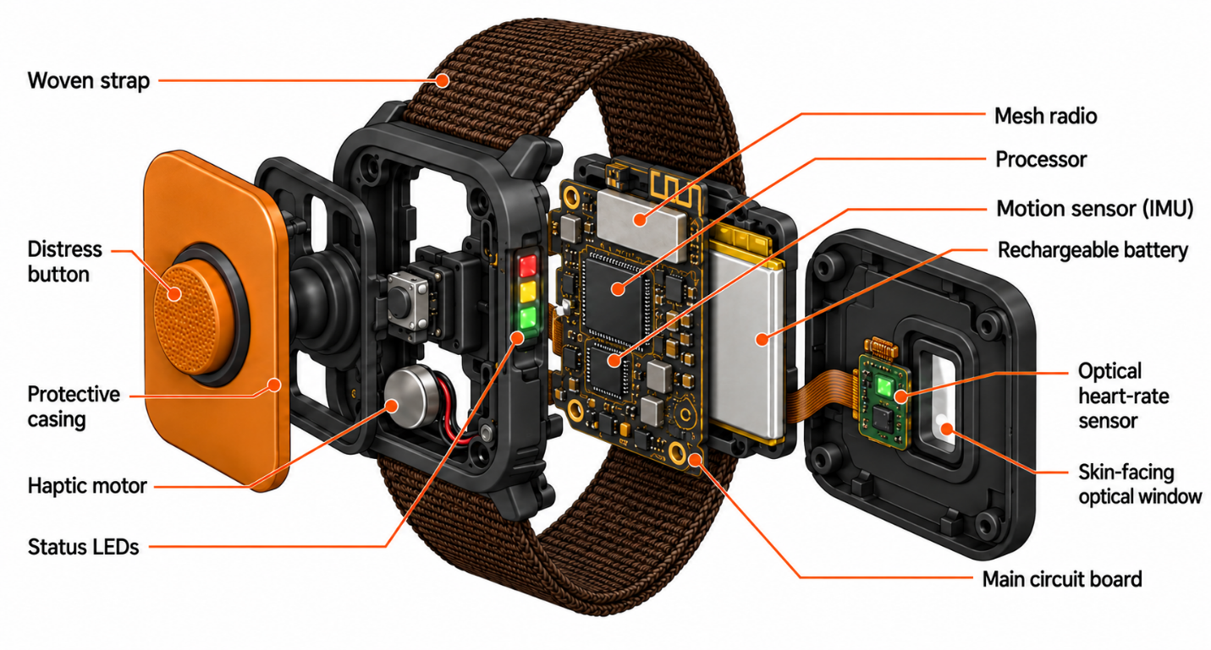
Appendix 1(Watch internal design)
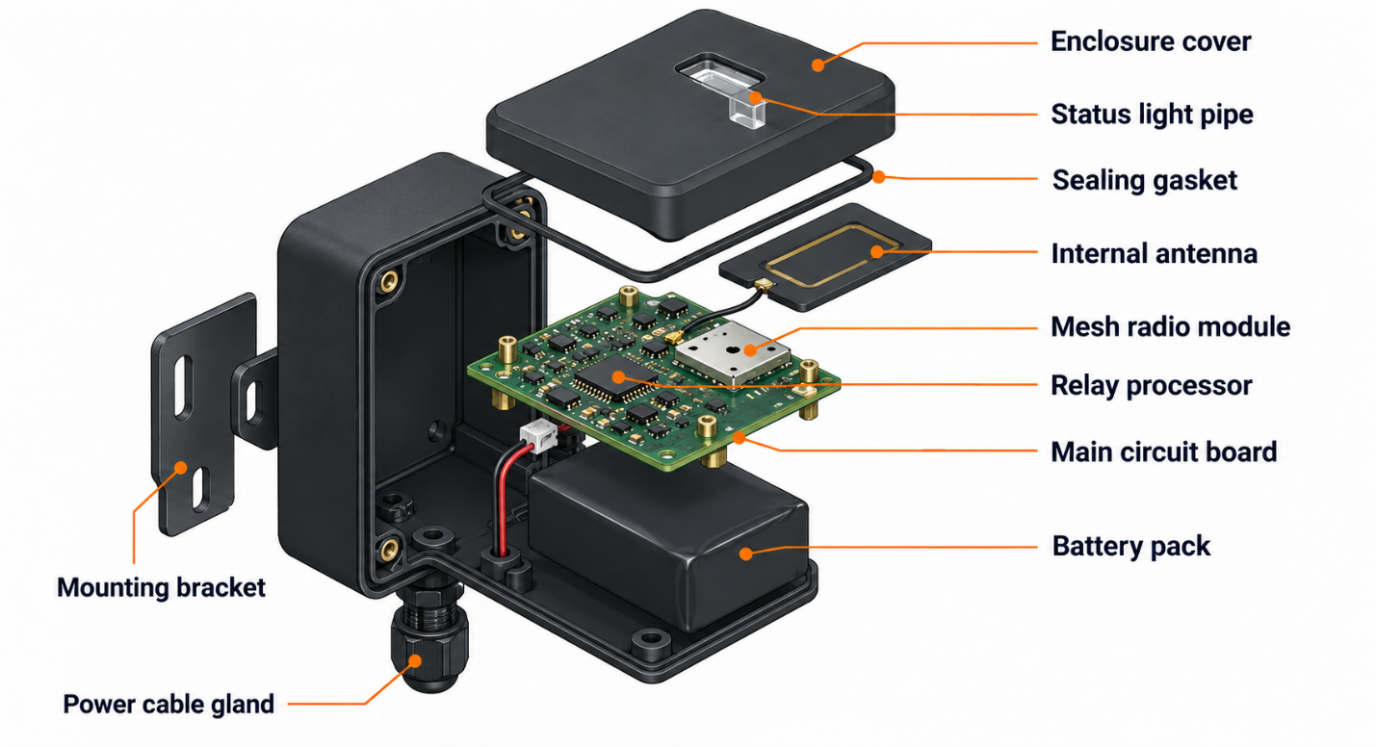
Appendix 2 - (Nodes design)

Appendix B: Competitive comparison of existing safety solutions and the proposed wearable
Comparison criterion | SlateSafety BAND V2 | Strata CommTrac | MRMON
Product type | Connected safety armband | Underground wireless  communication and tracking  network | Wrist wearable safety device connected to underground reference nodes
Primary purpose | Physiological monitoring, heat-stress prevention, and lone-worker safety. | Underground  communications  personnel tracking, and environmental monitoring | Coordinated worker status, location, and emergency alert management.
Worker monitoring | Monitors heart rate, exertion, estimated core body temperature, movement, and other physiological indicators | Tracks the location and direction of travel of personnel and equipment. | Connects worker status, location, man down detection, and distress alerts
Location capability | GPS and location zone functionality, depending on system configuration | Real-time personnel and equipment tracking through an underground mesh network. | Location tracking through underground reference nodes
Emergency communication | SOS TapAlert, no movement detection, vibration, LED feedback, and alerts to configured contacts. | Individual and group text messaging, distress notifications, and communication between underground personnel and surface operators | One-button emergency control with notifications sent to the supervisor and a designated nearly co-worker.
Worker interface | Arm worn device with vibration and LED indicators | Portable miner communicator with a screen and QWERTY keyboard; tracking tags may also include an emergency button | Simple, glove friendly, screenless wrist interface with physical button control
Supporting infrastructure | Wearable device, gateways beacons, and monitoring software | Fixed communication nodes operate for approximately 10 months; this figure is not directly comparable with wearable battery life. | Simple worker interaction combined with location linked alerts and a coordinated response workflow
Main positioning difference | Primarily focused on physiological risk and connected worker monitoring | Primarily focused on mine wide communication tracking infrastructure | Focused on an accessible wrist interface and delivering emergency information to two response roles
Table B1 Competitive comparison of existing safety solutions and the proposed wearable
Interviews were conducted between 1 and 28 September 2026 through face-to-face and telephone discussions. Participants were recruited through LinkedIn and contacts with Australian engineers. This summary contains no names or personal identifiers.

Participant group | Total participants | Reported response theme | Respondents identifying the theme | Percentage
Underground workers | 60 | Operation while wearing gloves | 48 | 80%
Supervisors and safety personnel | 25 | Worker-location information accompanying emergency alerts | 21 | 84%
Operations and procurement managers | 15 | Compatibility with existing systems | 12 | 80%
Table B2 Summary of Reported Interview Findings

Item | Description
Data collection period | 1–28 September 2026
Interview method | Face-to-face and telephone interviews
Recruitment channels | LinkedIn and contacts with Australian engineers
Total participants | 100
Participant groups | 60 underground workers; 25 supervisors and safety personnel; 15 operations and procurement managers
Question format | Open-ended questions exploring underground work challenges, unmet needs, and management concerns
Analysis method | Responses grouped into recurring themes, with each respondent counted once per relevant theme
Limitations | Recruitment was not random; findings reflect the interviewed sample and do not establish purchase commitments
Table B3 Interview Methodology
Table B3. Proposed Coding Criteria for Verification Against Interview Records
Theme code | Theme | Criterion for including a respondent | Calculation
W1 | Operation while wearing gloves | The respondent explicitly identified using controls while wearing gloves as a need, priority, or difficulty with existing devices. | 48 ÷ 60 × 100 = 80%
S1 | Location information with emergency alerts | The respondent explicitly identified receiving the affected worker’s location alongside an emergency alert as a need or priority. | 21 ÷ 25 × 100 = 84%
P1 | Compatibility with existing systems | The respondent explicitly identified compatibility or integration with existing site systems as a purchasing or deployment priority. | 12 ÷ 15 × 100 = 80%
Table B4 Proposed Coding Criteria for Verification Against Interview Records

Appendix C: Initial Reachable Market and Pilot Revenue Estimates
Measure | One pilot site | Two pilot sites
Wearables | 60 | 120
Reference nodes | 30 | 60
Paid pilot revenue | AUD 60,000 | AUD 120,000
Potential annual subscription revenue after the included first year | AUD 18,000 | AUD 36,000
Table C1 Initial Reachable Market and Pilot Revenue Estimates

Appendix D: Business model and value proposition canvases

Figure D1: Business model canvas
Figure D2: Value proposition canvas
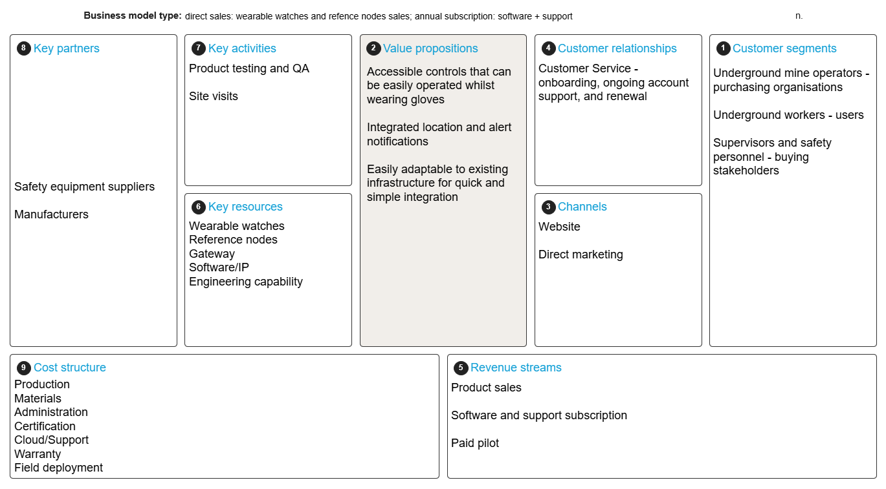
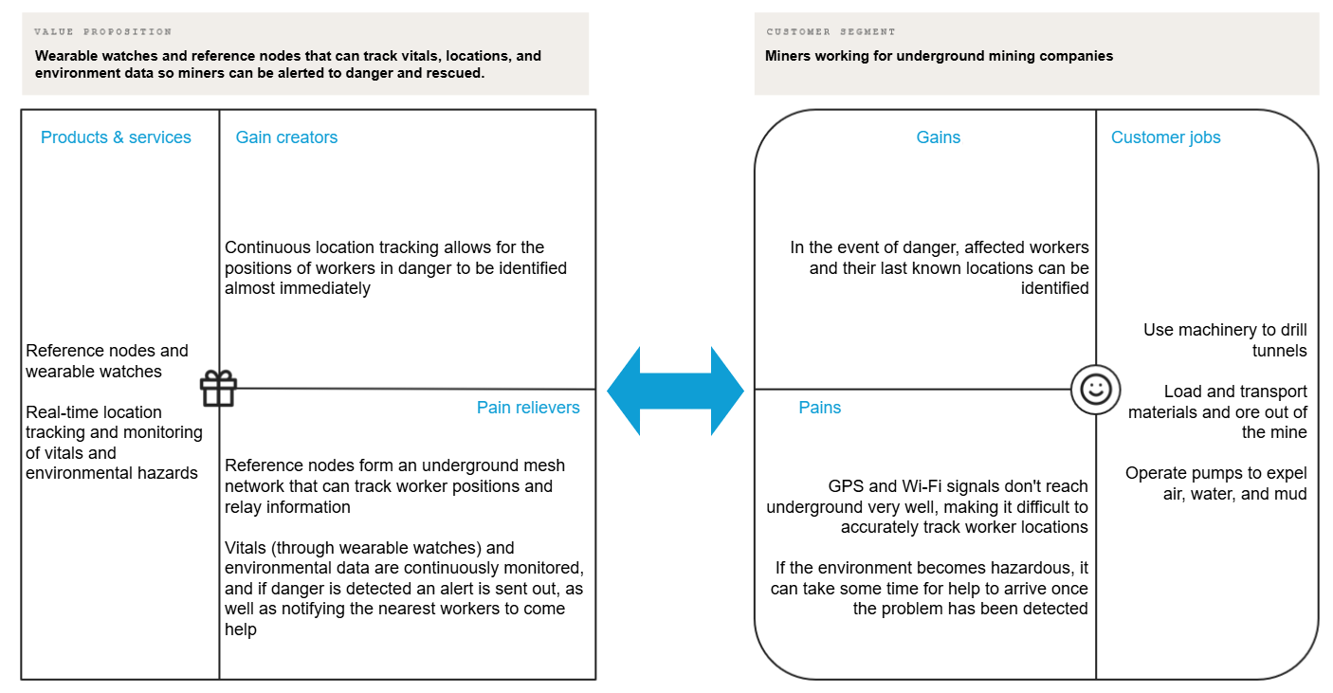
Figure D2: Value proposition canva

Appendix E: IP Timeline
Month | Action | Market link
Month 0 | Submitted the Australian provisional patent application and separate name and logo trademark applications. | This supports Australian launch preparations.
Month 1 | PCT application was filed, claiming priority from the provisional application. | Preserves the international patent pathway.
Month 2 | Early Australian national-phase entry completed, and the expedited examination was requested. | Helps advance Australian patent protection before launch.
Month 5 | Australian patent application accepted following successful examination and resolution of objections. | The three-month opposition period begins.
Month 8 | Both Australian trademarks registered. | This establishes domestic brand protection.
Month 9 | Australian standard patent granted following completion of the opposition period without opposition. | This establishes domestic patent protection.
Months 10-12 | Complete updated clearance searches and file separate Madrid applications for the name and logo, designating Canada and Chile. | This will seek overseas brand protection ahead of export promotion.
Month 24 | Confirm that Canada and Chile remain commercially justified before committing to national patent applications. | Aligns expenditure with demand and funding.
By Month 30 | Enter the Canadian and Chilean patent national phases by Month 30 (WIPO 2023c). | Supports Canada in Year 3 and preserves the Chilean pathway for Year 4.
After entry | Respond to examination reports and pursue overseas grant. | Continues protection as the business expands.

Appendix F: Detailed Budget and Pilot Targets
Department | Lead | Responsibilities
Executive and Strategy | Conan – CEO | Investor relations, pilot negotiations, scaling plan
Product and Engineering | Minh – Chief Product Officer | Product requirements, industrial design, management of engineering hires and contract manufacturer
Software Development | Lead Embedded Engineer (hire), reporting to CPO | Firmware, triage logic, mesh protocol, supervisor dashboard
Operations, WHS and Compliance | Merlin – COO | Supply chain, quality, certification program, IP filings
Marketing and Sales | Reham – Head of Marketing and Sales | Pilot sales, site demonstrations, trade events
Business Development | Owen – Head of Partnerships | Gas-detector and mine-communications vendor partnerships, distributors
Finance | Ngedup – CFO | Budgeting, fundraising, R&D Tax Incentive claims, reporting

Table F1: Detailed payroll calculation
Role | Start | Paid months to Month 18 | Salary cost before super (AUD)
Lead Hardware / Embedded Engineer (A$140,000 a year) | Month 1 | 18 | 210,000
Firmware and Mesh Engineer (A$110,000 a year) | Month 3 | 16 | 146,667
Field Support Technician (A$95,000 a year) | Month 13 | 6 | 47,500
Total salaries |  |  | 404,167
Superannuation at 12% |  |  | 48,500
Engineering team total (used in Sections 5.3 and Chapter 6) |  |  | 452,667
The payroll total excludes workers’ compensation insurance, recruitment fees and other on costs, which would be met from the reserve. Founders are not paid in this plan.

Table F2: Detailed 18-Month Budget
Use of funds (18 months from seed close) | AUD
Engineering team (salaries plus 12% superannuation; payroll table in Section 5.2) | 452,667
RF / hazardous-area design contractor (prospective, Months 6–18) | 60,000
MVP refinement, validation and production preparation (PCB revisions and design freeze, enclosures, components, pre-compliance test equipment) | 110,000
Pilot fleet (60 wearables, 30 nodes, gateway), capitalized | 40,000
Certification and compliance allowance: ingress, EMC/radio and other applicable compliance work 35,000; IECEx assessment 100,000 (scope to be confirmed by advisor and lab quotes) | 135,000
IP protection, planned stages only (international Madrid trademarks and national phase patent filings), capitalized | 31,476
Cloud hosting and software licenses | 20,000
Co-working office with electronics bench | 45,000
Insurance (product liability, professional indemnity) | 25,000
Field trials and site travel | 40,000
Marketing and trade events | 30,000
Legal, accounting and incorporation | 20,000
Total planned uses, before reserve | 1,009,143
Cash reserve, held unspent (5.96% of cash available at seed close; 6.33% of planned uses before reserve) | 63,911
Cash available at seed close (founder cash 123,054 + seed investment 950,000) | 1,073,054
Add: IP costs already paid by founders before seed close (completed patent and trademark stages) | 26,946
Total capital (founders 150,000 + seed investment sought 950,000) | 1,100,000

Table F3: Detailed operational resources
Resource | Plan
Office space | Co-working space in Canberra (4–6 desks) with an electronics bench; no long-term lease before seed close
Product testing | In-house bench testing. Compliance is a process, not a single test: for the RCM compliance mark MRMON needs the applicable standards, test evidence, declarations, registration and labelling, scoped with advisors and an accredited (NATA) test lab before work starts. Ingress (IP65/IP67), EMC/radio and other applicable compliance work sit in the A$35,000 allowance. IECEx assessment (A$100,000 allowance) is planned through an Ex-test lab such as TestSafe Australia, which is a prospective provider, with no agreement signed. Field validation takes place at the pilot site only.
Manufacturing | No in-house production. Australian non-prospective (not selected or contracted) contract electronics manufacturer intended to construct pilot batches (less than 500 units) for speed and IP control purposes; Volume production may go offshore after design freeze. Before any manufacturer is signed, MRMON will obtain quotes by scope of work, including retesting, production QA and tooling where applicable, and will agree terms on IP ownership, quality control, change control and the effect of design or component changes on certification. MRMON retains final QA and incoming inspection.
Software and cloud | Firmware toolchain, CAD and version control. The supervisor dashboard is planned for an Australian cloud region (provider to be selected). Choosing an Australian region fixes where primary data is stored; it does not on its own show that backups, vendor support access and data processing all stay in Australia. MRMON controls the region, encryption, access roles and retention settings; the provider must confirm where backups, support access and processing occur, and this will be checked before any customer data is stored.
Vehicles | None purchased; vehicles hired for site visits
Key suppliers | PPG and IMU sensors, mesh radio modules, certified lithium cells (cell-level certification does not certify the complete watch), polymer enclosure molding. All suppliers are prospective until contracts or purchase orders are signed.

Table F4: Scaling strategy
Phase | Timing | Milestones
1. Prove | Months 0–12 | MVP already built (Section 1.4); MVP refinement and design freeze by Month 6; compliance and pre-certification work begins; one paid pilot (60 wearables, 30 nodes) at an assessed and approved site, with the A$60,000 pilot fee received by Month 18 in the base case; pilot agreement, purchase order and price confirmation pursued in parallel with the technical milestones; pilot acceptance targets as set out below.
2. Expand in Australia | Months 12–24 | IECEx certification – scope and time to be confirmed in the laboratory; 3-5 sites across NSW, WA and QLD. It is a deployment and a target, not committed or forecast income: the single pilot is in the Chapter 6 forecast, and the other sites will start after Month 18 or may not be signed. Access to underground coal mines after IECEx and coal-specific approvals; initial partnership agreement with a distributor or vendor; Field technician close to major coal mining areas. As well as technical certification, signed partner agreements, purchase orders and price confirmation are tracked as milestones.
3. Adjacent and international | Months 24–48 | Metro and rail tunnelling projects; Canada in Year 3 (Months 25–36) and Chile in Year 4 (Months 37–48) through local distributors, each only after local approval, certification and regulatory requirements have been checked (IECEx recognition is not assumed to give automatic access). The United States is not in the current plan.

Table F5: Proposed Pilot Targets and Measurement Methods

KPI | Proposed target | Measurement basis
Alert-to-acknowledgement time | Median ≤ 60 s; 95th percentile ≤ 120 s | Time from SOS press or man-down trigger to acknowledgement by the supervisor or a nearby co-worker, from timestamped logs of drills and live events
False alarms | ≤ 2 per 100 worker-shifts after calibration | Automatic alerts later classed as false by supervisor review, reported with the number of shifts logged
Node coverage uptime | ≥ 98% of shift time in covered areas | Node heartbeat and gateway logs over the pilot period
Alert delivery | ≥ 99% of test alerts delivered to both supervisor and nearby co-worker | At least 30 staged drills across the covered area
Location accuracy | Correct node zone at ≥ 90% of check points | Walk tests at marked check points, reported location compared with actual zone

Appendix G: Balance sheet and Income Statement
Figure G1: Balance Sheet 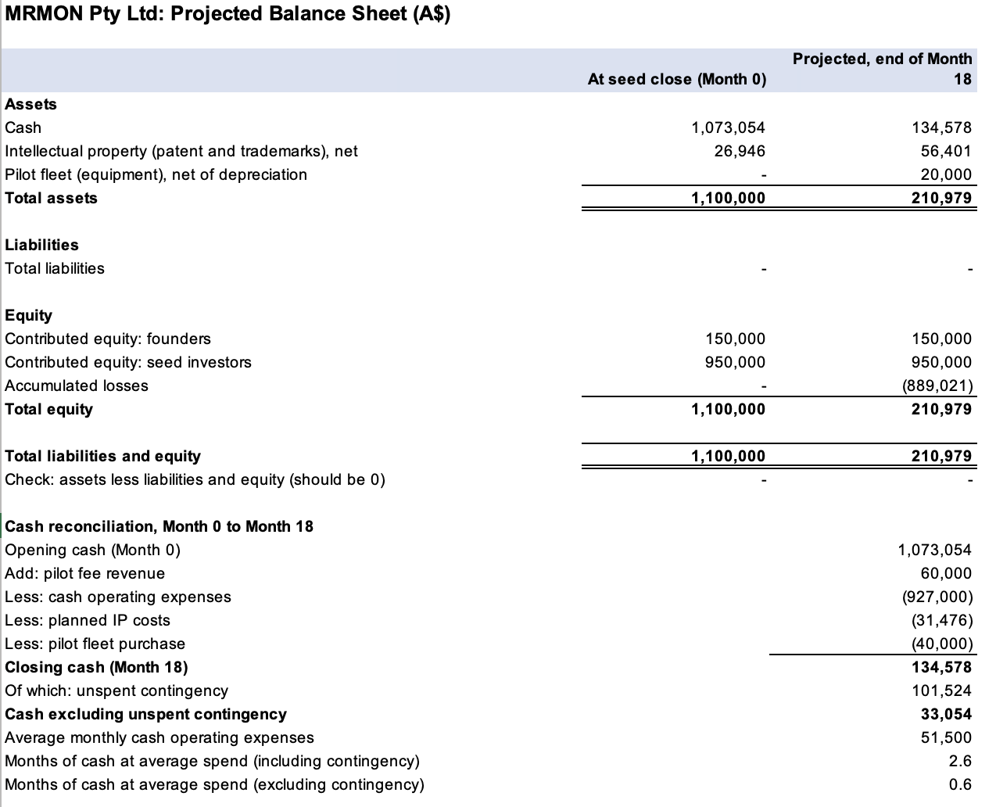
Notes
- Liabilities are zero because GST, wages payable and receivables are not included in the model.
- Cash at month 18 includes the unused contingency amount, as mentioned in the cash reconciliation.
- The IP at month 18 includes international costs that were planned and treated as if they were incurred by month 18. National phase entries need to be submitted by month 30, so part of this spending might happen later.
- The pilot fleet is being depreciated over a period of 36 months and is kept by MRMON
- Income tax and R&D

Appendix G: Figure G1: Income Statement
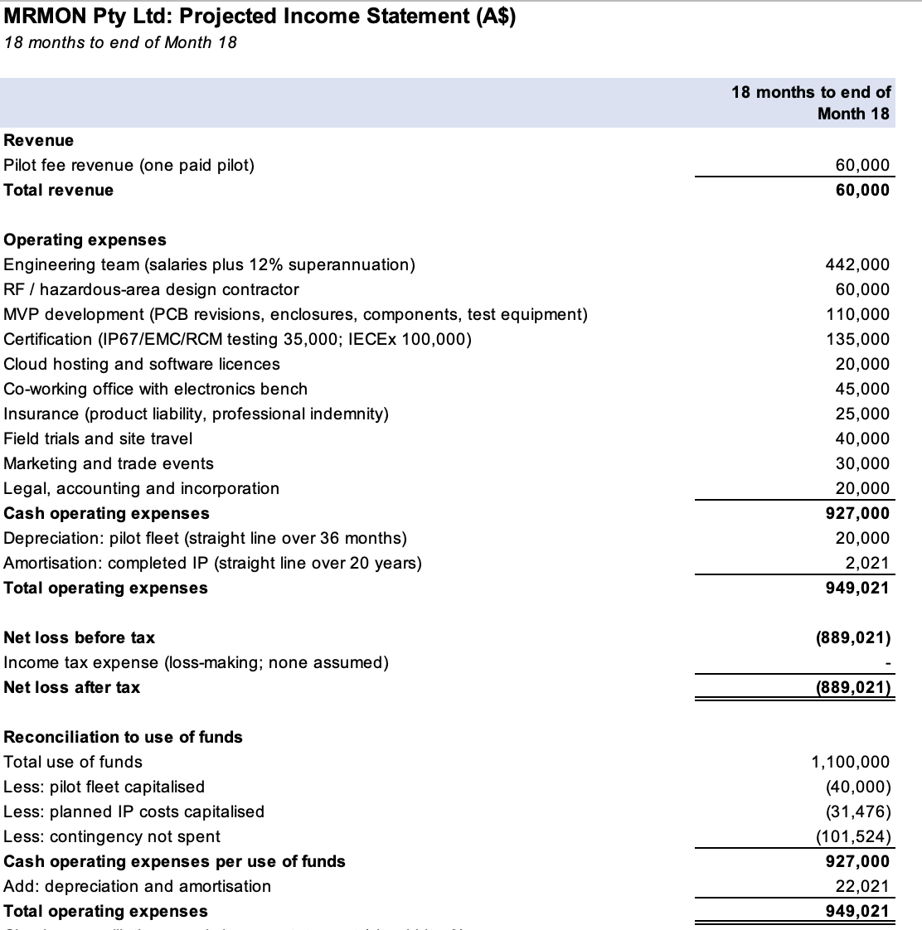
Notes
- Dashes (-) on the pilot fleet, IP protection, and contingency lines show amounts that are either capitalized or not yet spent, and these are checked and matched in the final block.
- The cost of obtaining an abortion is A$26,946 for 20 years, or A$2,021 for a period of 18 months.
- Planned IP is not amortized until incurred.
- Income tax and the R&D Tax incentive refund are not included.

References
Aurelia Metals. (n.d.). Peak. https://aureliametals.com/peak-mine/
Codelco. (n.d.). El Teniente. https://www.codelco.com/operaciones/el-teniente/el-teniente
Evolution Mining. (n.d.). Northparkes operations. https://evolutionmining.com/our-operations/northparkes/
Hughes, A., Britt, A., Pheeney, J., Kucka, C., Morfiadakis, A., Munns, C., Boyd, J., Senior, A., Cross, A., & Thorne, J. (2026). Australia’s identified mineral resources 2025. Geoscience Australia. https://doi.org/10.26186/150676
Jobs and Skills Australia. (2026). Mining. https://www.jobsandskills.gov.au/data/occupation-and-industry-profiles/industries/mining
Natural Resources Canada. (n.d.). Minerals and the economy. https://natural-resources.canada.ca/minerals-mining/mining-data-statistics-analysis/minerals-economy
NSW Productivity and Equality Commission. (2025). [Submission to the NSW Net Zero Commission concerning coal mining]. https://www.netzerocommission.nsw.gov.au/sites/default/files/2025-07/NSW%20Productivity%20and%20Equality%20Commission.pdf
Safe Work Australia. (2025). Key work health and safety statistics Australia 2025. https://data.safeworkaustralia.gov.au/sites/default/files/2025-10/Key_Work_Health_and_Safety_Statistics_Austraila_2025.pdf
SlateSafety. (n.d.). BAND V2. https://slatesafety.com/products/band-v2/
SlateSafety. (2024, September 4). What is a Tap Alert? https://support.slatesafety.com/article/18-what-is-a-tap-alert
Strata Worldwide. (n.d.). StrataConnect Wireless. https://www.strataworldwide.com/mining/strata-connect-mining/connect-wireless-mining
Strata Worldwide. (n.d.). StrataCONNECT Wireless (CommTrac): Wireless communications and tracking [Brochure]. https://www.strataworldwide.com/web/productsheets/Strata-Commtrac-Brochure-US-24_Web.pdf
CSIRO 2021, Csiro.au, CSIRO, viewed 18 October 2026, < https://www.csiro.au/en/research/technology-space/robotics/tracking-in-underground-mines >
IP Australia 2025a, Patent cooperation treaty fees change - 1 january 2026, Ipaustralia.gov.au, viewed 17 October 2026, < https://www.ipaustralia.gov.au/news-and-community/official-notices/change-in-PCT-fees-1-january-2026 >.
― 2025b, Trade mark timeframes and fees, Ipaustralia.gov.au, viewed 16 October 2026, < https://www.ipaustralia.gov.au/trade-marks/timeframes-and-fees >.
IP Australia n.d., The madrid system, www.ipaustralia.gov.au, viewed 16 October 2026, < https://www.ipaustralia.gov.au/international-ip/international-cooperation/the-madrid-system >.
WIPO 2005, Article-display, wipo-magazine, viewed 22 October 2026, < https://www.wipo.int/en/web/wipo-magazine/articles/ip-and-business-launching-a-new-product-freedom-to-operate-34956 >.
― 2023a, Individual fees under the madrid protocol, madrid-system, viewed 17 October 2026, < https://www.wipo.int/en/web/madrid-system/fees/ind_taxes >.
― 2023b, Madrid system: Schedule of fees, madrid-system, viewed 17 October 2026, < https://www.wipo.int/en/web/madrid-system/fees/sched >.
― 2023c, Time limits for entering national/regional phase under PCT chapters I and II, pct-system, viewed 18 October 2026, < https://www.wipo.int/en/web/pct-system/texts/time_limits >.
Australian Taxation Office (2025) The final SG rate increase is coming on 1 July. 5 June. Available at: <https://www.ato.gov.au/businesses-and-organisations/small-business-newsroom/the-final-sg-rate-increase-is-coming-on-1-july>.
Australian Taxation Office (2026) Rates of R&D tax incentive offset. Last updated 13 May. Available at: https://www.ato.gov.au/businesses-and-organisations/income-deductions-and-concessions/incentives-and-concessions/research-and-development-tax-incentive/r-d-tax-incentive-rates-and-entitlements/rates-of-r-d-tax-incentive-offset.

